# ASSIGNMENT 2.3:-

Step 1 & 2:- 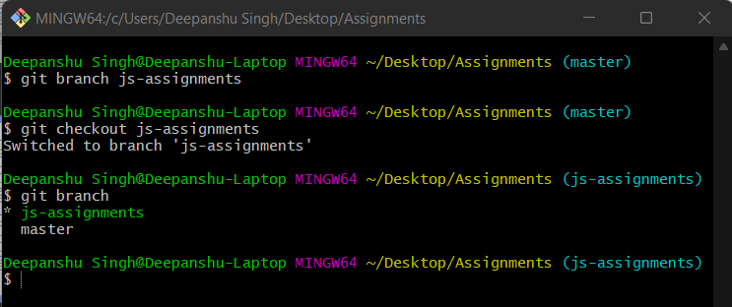

Step 3 & 4:- 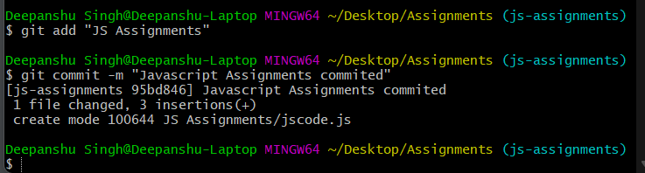

Step 5 & 6:- 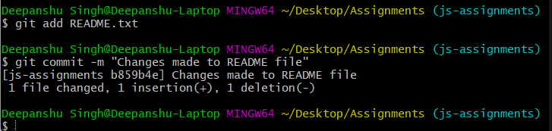

Step 7:- 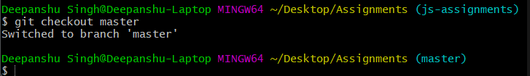

Step 8:- 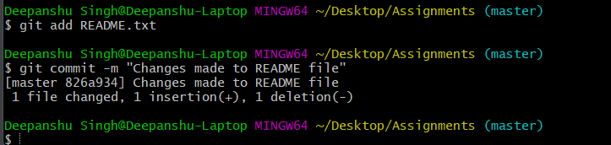

Step 9:- 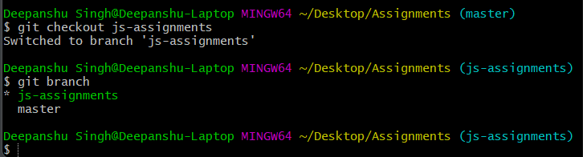

Step 10 & 11:- 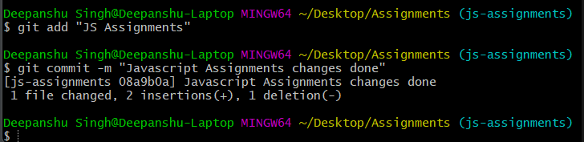

Step 12:- 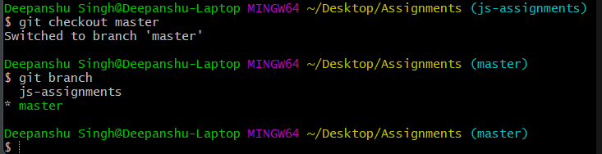

Step 13:- 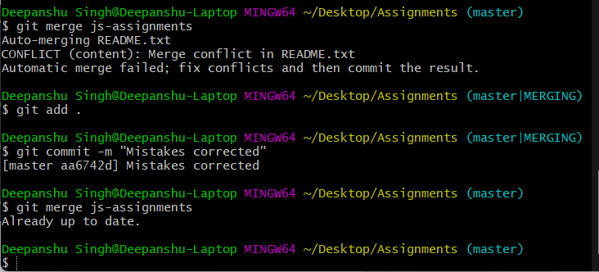

Step 14:- 